| Data Dictionary  By Wilton Ngo |
| --- |

# 

# Table of Contents

**Entity Relationship Diagram** **3**

**Fact Table** **4**

**Rental Table** **5**

**Payment Table** **6**

**Film_Actor Table** **7**

**Actor Table** **7**

**Inventory Table** **8**

**Film Table** **8**

**Language Table** **10**

**Category** **10**

**Customer Table** **11**

**Staff Table** **12**

**Store Table** **13**

**Address Table** **13**

**City Table** **14**

**Country Table** **15**

# Entity Relationship Diagram

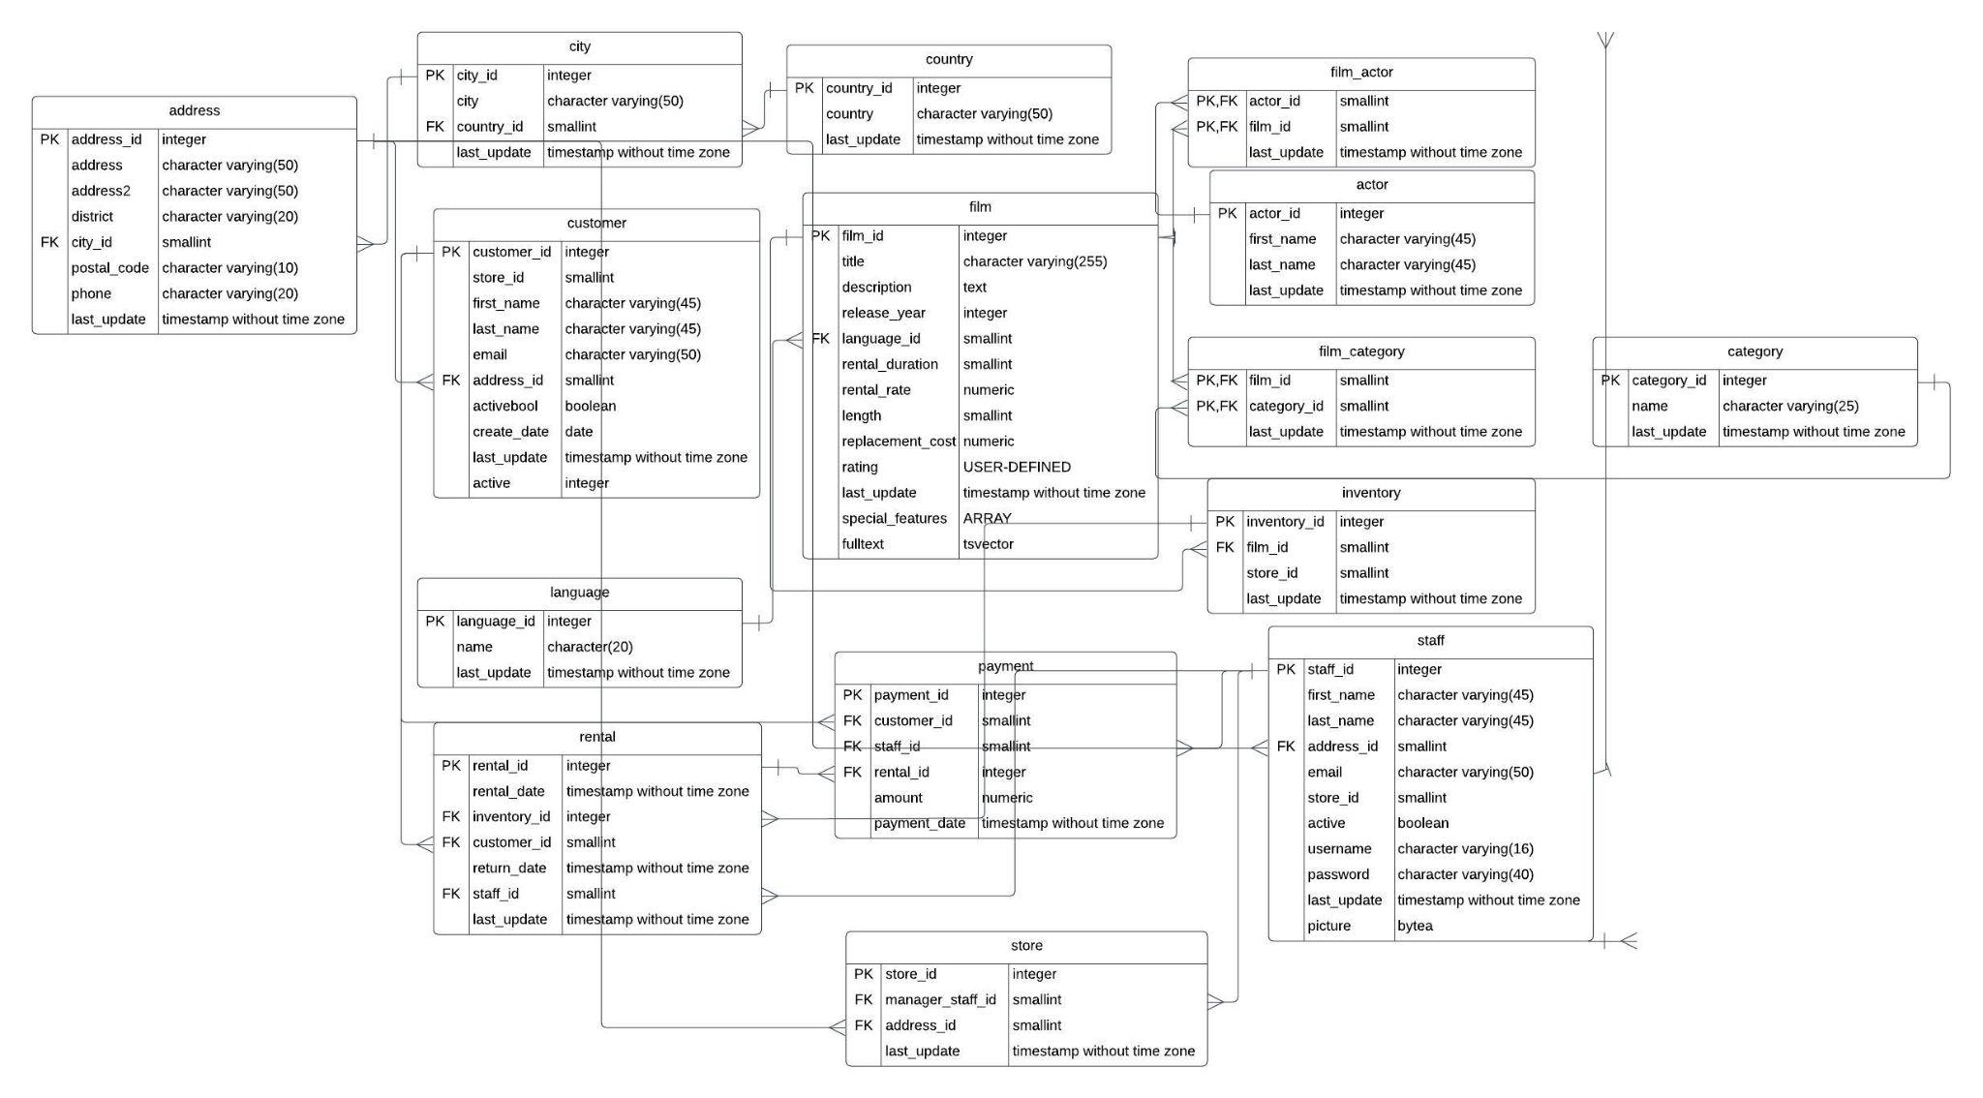

The ER Diagram of Rockbuster Database. The primary keys and Foreign keys and the relationship between the tables.

# Fact Table

|  |  | Rental Table |  |
| --- | --- | --- | --- |
| Key | Column | Data Type | Description |
| Primary | rental_id | serial | ID of rental |
|  | rental_date | Timestamp w/o Time Zone | Date of Rental |
| Foreign | inventory_id | integer | ID of Inventory |
| Foreign | coustomer_id | smallint | ID of Customer |
|  | return_date | Timestamp w/o Time Zone | Date it was returned |
| Foreign | staff_id | smallint | Id of Staff |
|  | last_update | Timestamp w/o Time Zone | last update of table |

Rent Table Links to

| Table | Link |
| --- | --- |
| Customer | payment.customer_id = customer.customer_id |
| Staff | payment.staff_id = staff.staff_id |
| rental | payment.inventory_id = inventory.inventory_id |

Rent Table Links From:

| Table | Link |
| --- | --- |
| Payment | payment.rental_id = rental.rental_id |

This where you rent the movies for how long

|  |  | Payment Table |  |
| --- | --- | --- | --- |
| Key | Column | Data Type | Description |
| Primary | payment_id | integer | ID of payment |
| Foreign | customer_id | smallint | Id of customer |
| Foreign | staff_id | smallint | id of staff |
| Foreign | rental_id | integer | id of rental |
|  | amount | numeric | Cost of rental |
|  | payment_date | Timestamp W/o TimeZone | Cost of rental |

Payment Table Links to:

| Table | Link |
| --- | --- |
| Customer | payment.customer_id = customer.customer_id |
| Staff | payment.staff_id = staff.staff_id |
| Rental | paument.rental_id = rental.rental_id |

Payment table Links From: N/A

Payment table to see how you paid to rent the movies.

Dimensions Table:

# Film_Actor Table

| Key | Column | Data Type | Description |
| --- | --- | --- | --- |
| Primary | actor_id | smallint | id of actor |
| Foreign | film_id | small int | id of film |
|  | last_update | Timestamp w/o Timezone | Last update of table |

Film_actor Table Links to:

| Table | Link |
| --- | --- |
| Film | film_actor.film_id= film.film_id |
| Actor | film_actor.film_id= actor.actor_id |

Film_actor table Links from: N/A

To see what actors play in each film.

|  |  | Actor Table |  |
| --- | --- | --- | --- |
| Key | Column | Data Type | Description |
| Primary | actor_id | Serial | id of inventory film |
|  | first_name | Character varying(45) | Actor of First Name |
|  | last_name | Character varying(45) | Actor Last Name |
|  | last_update | Timestamp w/o Timezone | Last update of table |

Actor table Links to: N/a

Actor Table Links from :

| Table | Link |
| --- | --- |
| Film Actor | film_actor.actor_id = actor.actor_id |

The name of the actors.

|  |  | Inventory Table |  |
| --- | --- | --- | --- |
| Key | Column | Data Type | Description |
| Primary | inventory_id | serial | id of inventory film |
| Foreign | film_id | smallint | id of film |
| Foreign | store_id | smallint | ID of store |
|  | last_update | Timestamp w/o Timezone | Last update of table |

Inventory table Links to:

|  |  |
| --- | --- |
| Table | Link |
| Film | inventory.film_id = film.film_id |

Inventory table links from:

| Table | Link |
| --- | --- |
| rental | inventory.inventory_id = rental.inventory_id |

What is their inventory for each film in each store? So customers can rent the film.

|  |  | Film Table |  |
| --- | --- | --- | --- |
| Key | Column | Data Type | Description |
| Primary | film_id | serial | ID for film |
|  | title | character Varying(255) | Title of Film |
|  | description | text | Description Of Film |
|  | release_year | year | Year Of Film was released |
| Foreign | lanague_id | smallint | ID for Language |
|  | rental_duration | smallint | Duration of Rental |
|  | rental_date | numeric(4,2) | Date of Rental |
|  | length | smallint | Length of Film |
|  | replacement_cost | numeric(5,2) | Replacement cost of film |
|  | rating | maa_rating | Rating of film |
|  | last_update | Timestamp W./o Time Zone | Last update of table |
|  | special_features | text | Features of film |
|  | fulltext | tscextor | film index |

Film table Links to:

| Table | Link |
| --- | --- |
| language | film.language_id = language.language_id |
| Store | inventory.inventory_id = store.inventory_id |

Film Table Links from:

| Table | Link |
| --- | --- |
| inventory | film.film_id = inventory.film_id |
| Film Actor | film.film_id = film_actor.film_id |
| film Category | film.film_id = film.film_category_id |

A brief summary of the film that you want to watch.

|  |  | Language Table |  |
| --- | --- | --- | --- |
| Key | Column | Data Type | Description |
| Primary | language_id | serial Id | Id of language |
|  | name | character(20) | Name of Language |
|  | last_update | Timestamp W/o Time Zone | Last Update of table |

Language Table Links to: N/A

Language Table Links from

| Table | Link |
| --- | --- |
| Film | language.language_id = film.language_id |

The language that people are speaking in the film

|  |  | Category |  |
| --- | --- | --- | --- |
| Key | Column | Data Type | Description |
| Primary | category_id | serial Id | Id of Category |
|  | name | character varying(25) | Name of category |
|  | last_update | Timestamp W/o Time Zone | Last Update of table |

Category Table Links to N/A:

Category Table Links from:

The genre of the film

| Table | Link |
| --- | --- |
| film Category | Category.category_id = film_category.category_id |

|  |  | Customer Table |  |
| --- | --- | --- | --- |
| Key | Column | Data Type | Description |
| Primary | customer_id | serial Id | Id of Customer |
|  | store_id | smallint | ID of store |
|  | first_name | character varying(45) | Customer first name |
|  | last_name | character varying(45) | Customer last name |
|  | email | character varying(50) | Customer email address |
| Foreign | address_id | smallint | Id of Address |
|  | activebool | Boolean | Whether the Customer is ID |
|  | Create_date | date | Date Customer is created |
|  | last_update | Timestamp W/o Time Zone | Last Update of table |
|  | active | integer | Active Integer |

Customer Table Links to :

| Table | Link |
| --- | --- |
| Address | customer.address_id = address.address_id |

Customer Table Links From:

| Table | Link |
| --- | --- |
| Rental | customer.customer_id = rental.customer_id |
| Payment | customer.customer_id = payment.customer_id |

The people who are buying the film.

|  |  | Staff Table |  |
| --- | --- | --- | --- |
| Key | Column | Data Type | Description |
| Primary | staff_id | serial Id | Id of Staff |
|  | first_name | character varying(45) | staff first name |
|  | last_name | character varying(45) | staff last name |
| Foreign | address_id | smallint | Id of Address |
|  | email | character varying(50) | Staff Email address |
|  | store_id | smallint | Id of Store |
|  | active | boolean | Where the staff is active |
|  | username | character varying(16) | Staff username |
|  | password | character varying(40) | Staff Password |
|  | last_update | Timestamp W/o Time Zone | Last Update of table |
|  | picture | byte | Staff Photo |

Staff Table Links to:

| Table | Link |
| --- | --- |
| Address | staff.address_id = address.address_id |

Staff Table Links From:

| Table | Link |
| --- | --- |
| Payment | staff.staff_id = payment.staff_id |
| store | staff.staff_id = store.staff_id |
| Rental | staff.staff+id = rental.staff_id |

The staff for the people who work at the store

|  |  | Store Table |  |
| --- | --- | --- | --- |
| Key | Column | Data Type | Description |
| Primary | store_id | serial Id | Id of Store |
| Foreign | manager_staff_id | smallint | Id oof manager |
| Foreign | adress_id | smallint | Id of Address |
|  | last_update | Timestamp W/o Time Zone | Last Update of table |

Store Table Links To:

| Table | Link |
| --- | --- |
| staff | store.manager_staff_id = staff.staff_id |
| address | store.address_id = address.address_id |
| Rental | staff.staff+id = rental.staff_id |

Store Table Links From:N/A

The store where people buy the film and where they located at

|  |  | Address Table |  |
| --- | --- | --- | --- |
| Key | Column | Data Type | Description |
| Primary | address_id | serial Id | Id of Address |
|  | address | character varying(50) | Address line 1 |
|  | address | character varying (50) | Adressline 1 |
|  | district | character varying(20) | District |
| Foreign | city_id | smallint | Id of City |
|  | postal_code | character varying(10) | Postal Code |
|  | Phone | character varying(20) | Phone Number |
|  | last_update | Timestamp W/o Time Zone | Last Update of table |

Address Table Links to :

| Table | Link |
| --- | --- |
| City | address.city_id = city.city_id |

Address Table Links From:

| Table | Link |
| --- | --- |
| customer | address.adress_id = customer.address_id |
| store | address.adress_id = store.address_id |
| staff | address.adress_id = staff.address_id |

The address where the customer buy the film in the store

|  |  | City Table |  |
| --- | --- | --- | --- |
| Key | Column | Data Type | Description |
| Primary | city_id | serial Id | Id of City |
|  | city | character varying(50) | City Name |
| Foreign | country_id | smallint | Id of country |
|  | last_update | Timestamp W/o Time Zone | Last Update of table |

City Table Links to:

| Table | Link |
| --- | --- |
| country | city.country_id = country.country_id |

City table Links from:

| Table | Link |
| --- | --- |
| address | city.city_id = address.city_id |

The city where the customer buy the film

|  |  | Country Table |  |
| --- | --- | --- | --- |
| Key | Column | Data Type | Description |
| Primary | country_id | serial Id | Id of country |
|  | country | character varying(50) | Last Update of table |
|  | last_update | Timestamp W/o Time Zone | Last Update of table |

Country Table Links to: N/A

Country table Links From:

| Table | Link |
| --- | --- |
| city | country.country_id = city.country_id |

The country where the customer buy the film.